*Heaven’s light is our guide.*

**Rajshahi University of Engineering and Technology**

**(RUET)**

**Department of Electrical & Electronic Engineering**

**Course no.** EEE2204

**Course title:** Electronics III Sessional

**Experiment no.** 02

**Experiment name:** Experimental study of a clamper circuit using passive elements.

**Submitted to:**

**Dr. Md. Samiul Habib**

Associate Professor

Dept. of Electrical & Electronic Engineering,

Rajshahi University of Engineering and Technology.

**Submitted by:**

**Ashraf Al- Khalique**

**Roll:** 1801171; **Session:** 2018-2019

Dept. of Electrical & Electronic Engineering,

Rajshahi University of Engineering and Technology.

**Date of experiment:** January 28, 2021.

**Date of submission:** February 04, 2021.

**Experiment no**. 02

**Name of the Experiment:** Experimental study of a clamper circuit using passive elements.

**Objectives:** Followings are the main objectives of this experiment,

1. To understand the theory of operation of the clamper circuit using passive elements.
2. To study the diode applications in a clamper circuit using passive elements.
3. To observe wave shapes that meet the clamper circuit’s needs.

**List of Components:**

1. Function Generator (-10V- 10V;0.5msec- 1msec)
2. DC power supply (5V)
3. Resistors (151kΩ; 1 piece)
4. Diode (1N 4007; 1 piece)
5. Oscilloscope
6. Project board
7. Capacitor (1µF; 1 piece)
8. Connecting wires
9. Simulator (Multisim 11.0)

**Circuit diagram:**



***Fig 1.1:*** *Circuit diagram for Biased* *positive clamper circuit.*

**

***Fig 1.2:*** *Circuit diagram for Biased* *negative clamper circuit.*

**Waveshape:**

1. **Biased positive clamper circuit:**

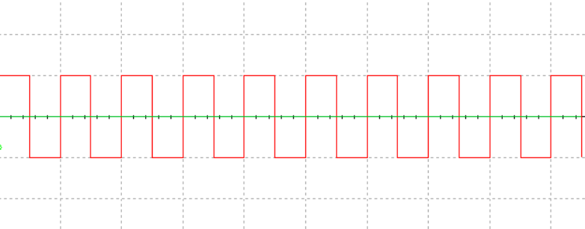

***Graph 1.1:*** *Input signal for biased positive clamper circuit.*

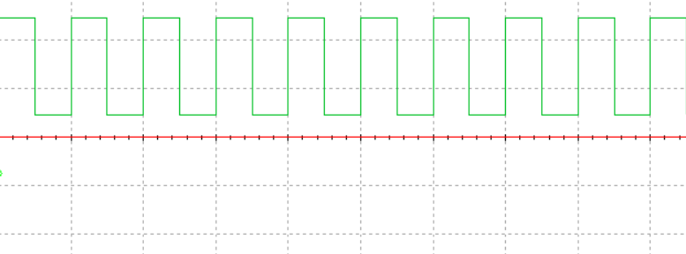

***Graph 1.2:*** *Output signal* *for biased positive clamper circuit.*

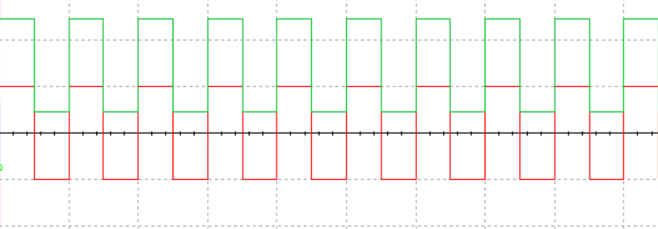

***Graph 1.3:*** *Input and output signal for biased positive clamper circuit.*

1. **Biased negative clamper circuit:**

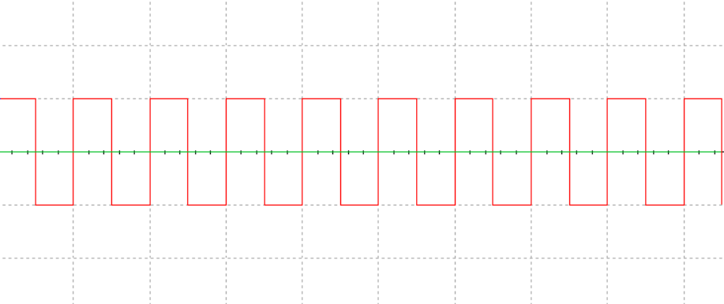

***Graph 2.1:*** *Input signal for biased negative clamper circuit.*

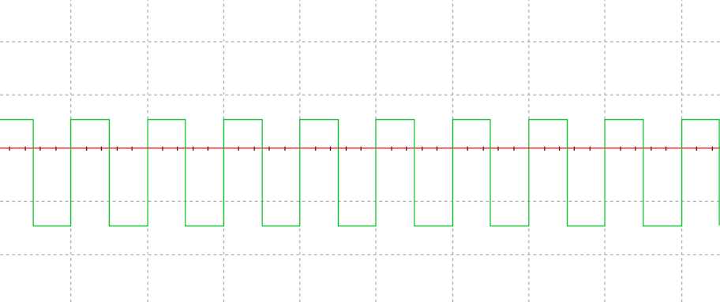

***Graph 2.2:*** *Output signal for biased negative clamper circuit.*

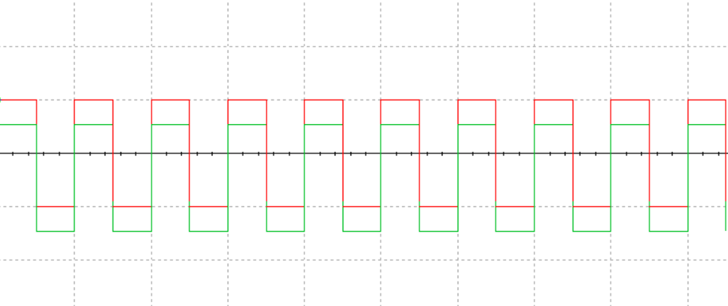

***Graph 2.3:*** *Input and output signal for biased negative clamper circuit.*

**Result:**

For a biased positive clamper circuit, positive half cycle output was around 24.5V, and for negative half cycle, output was 4.5V.

For a biased negative clamper circuit, positive half cycle output was around 5.3V, and for negative half cycle, output was -14.58V.

**Conclusion:**

For a biased positive clamper circuit, in the positive half cycle, the diode was c. Therefore, 24.5V was measured due to the diode being open. But for the negative half cycle, the diode was in conduction mode. So, the output was around 4.54V with around 0.45V drop across the diode.

For a biased negative clamper circuit, for a positive half cycle, the diode was in conduction mode. So, the output was 5.370V with a slight voltage drop across the diode and a DC source of 5V. For the negative half cycle, the diode was 5.370V meaning an open circuit. So output was stored voltage in the capacitor. So, the amplitude was -14.582V